More efficiency, security and availability

Forward-looking redesign of the successful Melkus Mechatronic pallet AGV: The new version 3.0 of the Melkus G130 impresses with several technical innovations. Its fast transverse travel and optimised charging concept providing availability for a full shift are clear advantages for customers. The new version of the highly efficient pallet automated guided vehicle AGV will be presented in Stuttgart at the LogiMAT show from 24 to 26 March 2026.

Goeming/Salzburg, 10.02.2026 – The Melkus G130 pallet AGV performs important tasks in material flow by moving under, lifting and transporting load carriers in Euro pallet format. Features such as its high tolerance to uneven floors, its ability to turn on the spot, its long range on a single battery charge and its particularly low maintenance requirements make it very popular with operators of intralogistics systems.

That makes the Melkus G130 is one of Melkus Mechatronic's bestsellers. At the LogiMAT 2026 show, the independent Austrian manufacturer will present the Melkus G130 3.0, a new generation of its successful product. The focus of the redesign, which goes far beyond a mere model update, was on increasing the vehicle's efficiency and availability.

Hours of uninterrupted operation

One innovation of the Melkus G130 3.0 is its optimised battery and charging concept. The new AGV has a LiFePo4 battery with a significantly higher charging capacity. This ensures a significantly longer uninterrupted operating time for the vehicle between charging breaks. These remain within the previous time frame, as the battery is charged at the new inductive charging stations, which are standard for all Melkus AGVs and have a higher charging capacity than before. This has a significant impact on the AGV’s operational readiness: The actual operating time between charging breaks is influenced by many factors, but with the G130 3.0 it can last for an entire shift.

Fast transverse travel with uncompromised safety

The G130 has already made a name for itself with its omnidirectional drive, which allows it to be used in confined spaces with a minimum turning radius. Separately arranged supply and control technology for each skid and an electronic differential gear ensure separate drive and thus high tolerance to uneven ground, while the modular design with standardised turntable drives keeps maintenance requirements particularly low.

A pioneering feature of the Melkus G130 3.0 is its genuine 360° panoramic view, achieved with multiple overlapping LIDAR sensors. This not only ensures elevated levels of functional safety significantly exceeding the minimum regulatory requirements. It also eliminates previous limitations of omnidirectional driving.

This allows the G130 3.0 to travel at full speed regardless of its orientation, for example with the load at the front or at a 90° angle to the direction of travel in the rack aisle. This eliminates the need for many time-consuming turning and positioning manoeuvres. The use of LIDAR sensors for a 360° panoramic view also allows orders to be completed more quickly, saving time. All in all, this significantly increases the efficiency of internal transports.

“Among the most frequently heard customer requests is the ability to operate an AGV without charging breaks throughout an entire shift. With the new battery and charging concept of the Melkus G130 3.0 pallet AGV, this goal is now within reach,” explains Martin Lindner, CEO of Melkus Mechatronic. “In addition, the upgrade to the sensor technology for true 360° all-round visibility increases both the safety and efficiency of the vehicles.”

The new Melkus G130 3.0 will be on display at the Melkus Mechatronic LogiMAT booth, Hall 8, booth 8A67, delivery will commence this summer.

Image Captions

The Melkus G130 3.0 is a new power AGV with electric differential gear for high-speed travel, true 360° all-round safety and a highly efficient battery and charging concept.  All images, unless otherwise stated: Melkus Mechatronic. | 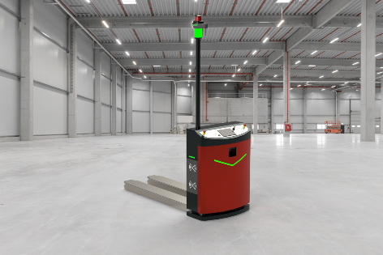
Martin Lindner, CEO of Melkus Mechatronic:  “With the new battery and charging concept of the Melkus G130 3.0 pallet AGV, the goal of operating an AGV for a full shift without a charging break is within reach. In addition, upgrading the sensor technology for true 360° all-round visibility increases both the safety and efficiency of the vehicles.” | 

About Melkus Mechatronic
Melkus Mechatronic GmbH is an innovative technology company based in Salzburg. With more than ten years of experience in the field of AGVs and mobile robotics, it provides customers with highly available AGVs for flexible in-house transport with maximum reliability. Swiftly installed and commissioned, these enable Melkus operators to organise their intralogistics more efficiently and to establish resource-saving processes. Melkus employs highly qualified and committed staff and offers a range of six AGVs for a wide variety of applications. www.melkus-mechatronic.com

